

GoPro MAX

# Ensure GPS is on



# 🚗 Driving Setup

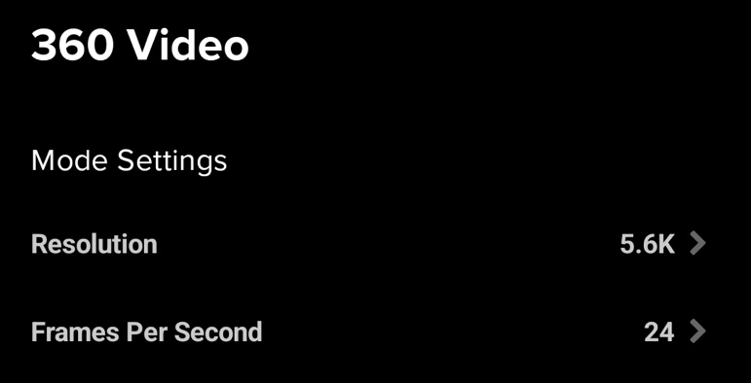

360 videos at 24 frames per second and 5.6K resolution.

**Tips:**

* Secure the GoPro MAX camera onto a vehicle suction mount or your vehicle’s roof rack system.
* Place the camera close to the center of the vehicle with the LCD screen facing the back of the car. Adjust the angles of the mounts so that the camera’s lenses face the front and back of your vehicle.
* Remove objects obstructing the camera view (such as the vehicle antenna).
* Connect and secure a power bank if your session will continue for 2 hours or more.

# 🚲 Biking Setup (up to ~22 mph or 35 km/h)

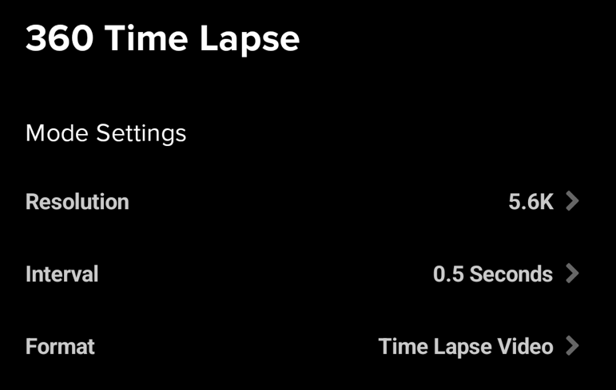

360 time-lapse video at an interval of 0.5 seconds and 5.6K resolution.

# 🚶‍♂️Walking Setup (up to ~5 mph or 8 km/h)

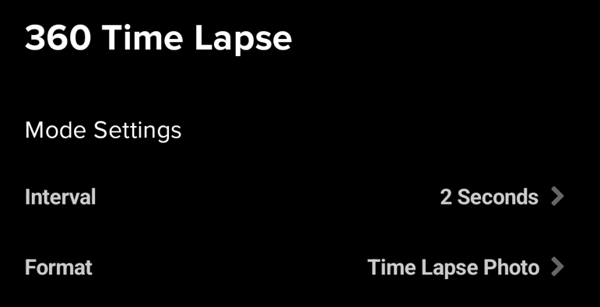

360 time-lapse photos (one frame every 2 seconds, 16MP resolution).

**Tips:**

* Charge your GoPro fully before embarking on a capture adventure, or carry a power bank if your session lasts over 2 hours.
* We recommend using a selfie stick when walking.
* You can either hold the stick in your hand or fasten it to a backpack in a steady, upright position.
* Be sure to keep the camera at least 30 cm above your head to minimize interference from your head.